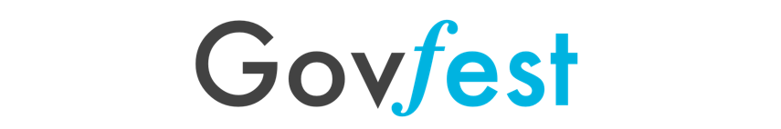
WINE + ART SOIRÉE 2024
2024 Silent Art Auction
Please fill out for each artwork entry and send to govfest.art@gmail.com by Monday, November 4, 2024, 11:59 p.m. Artists may submit images of up to four (4) artworks. All entries must be submitted in digital jpg format. Each jpg must be no more than 1.5 MB in size, and labeled as follows: “Last Name, First Name, Title,.jpg”.
For all sold artworks donated by artists, a charitable receipt will be issued for your donations. They will be sent to all artists after the event.
Please email this form completed along with your digital artwork images. Please complete all fields below.
About Yourself:
Artist Name:
Are you an employee or a family/friend with the Ontario Public Service (OPS) or the Toronto Public Service (TPS)?
Do you give permission for Govfest to use images of your work for promotional purposes?
How many times have you contributed/donated art to the Govfest Wine and Art Soirée in prior years?
Do you have online and/or social media (Website, Facebook, Twitter, Instagram, etc.) presence for your art? If so, please include the URL or handle.
By participating, you agree to providing 100% of sale proceeds to GovFest charities
Email
Phone No.
Mailing Address (required for charity receipt purposes)

Artwork # 1:
Title:
Medium: (e.g. acrylic, oil on canvas, pencil, watercolour, etc.)
Size (inches)
Retail Price: (no higher than $300)

Artwork # 2:
Title:
Medium: (e.g. acrylic, oil on canvas, pencil, watercolour, etc.)
Size (inches)
Retail Price: (no higher than $300)

Artwork # 3:
Title:
Medium: (e.g. acrylic, oil on canvas, pencil, watercolour, etc.)
Size (inches)
Retail Price: (no higher than $300)

Artwork # 4:
Title:
Medium: (e.g. acrylic, oil on canvas, pencil, watercolour, etc.)
Size (inches)
Retail Price: (no higher than $300)

